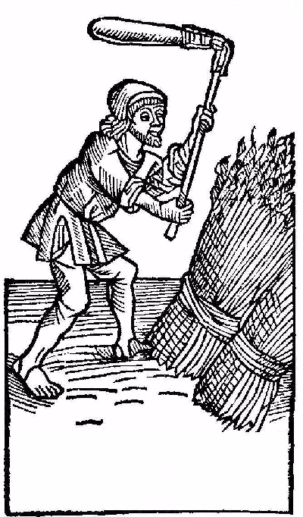
Label copyright (c) 2004 Joyce C. Hersh
Label copyright (c) 2004 Joyce C. Hersh
Label copyright (c) 2004 Joyce C. Hersh
Label copyright (c) 2004 Joyce C. Hersh
Label copyright (c) 2004 Joyce C. Hersh
Label copyright (c) 2004 Joyce C. Hersh
Label copyright (c) 2004 Joyce C. Hersh
Label copyright (c) 2004 Joyce C. Hersh
My Great Beer
John Smith 2003
My Great Beer
John Smith 2003
My Great Beer
John Smith 2003
My Great Beer
John Smith 2003
My Great Beer
John Smith 2003
My Great Beer
John Smith 2003
My Great Beer
John Smith 2003
My Great Beer
John Smith 2003

