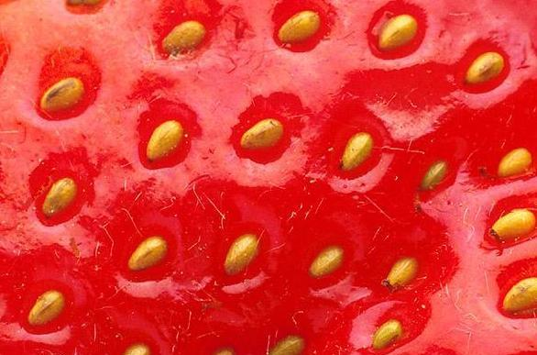
Strawberry Wine John Smith 2003
Strawberry Wine John Smith 2003
Strawberry Wine John Smith 2003
Strawberry Wine John Smith 2003
Strawberry Wine John Smith 2003
Strawberry Wine John Smith 2003
Strawberry Wine John Smith 2003
Strawberry Wine John Smith 2003
Label copyright (c) 2004 Joyce C. Hersh
Label copyright (c) 2004 Joyce C. Hersh
Label copyright (c) 2004 Joyce C. Hersh
Label copyright (c) 2004 Joyce C. Hersh
Label copyright (c) 2004 Joyce C. Hersh
Label copyright (c) 2004 Joyce C. Hersh
Label copyright (c) 2004 Joyce C. Hersh
Label copyright (c) 2004 Joyce C. Hersh

