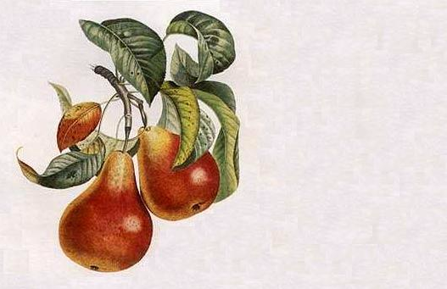

Pear
Mead

John Smith
2003

Pear
Mead

John Smith
2003

Pear
Mead

John Smith
2003

Pear
Mead

John Smith
2003

Pear
Mead

John Smith
2003

Pear
Mead

John Smith
2003

Pear
Mead

John Smith
2003

Pear
Mead

John Smith
2003
Label copyright (c) 2004 Joyce C. Hersh
Label copyright (c) 2004 Joyce C. Hersh
Label copyright (c) 2004 Joyce C. Hersh
Label copyright (c) 2004 Joyce C. Hersh
Label copyright (c) 2004 Joyce C. Hersh
Label copyright (c) 2004 Joyce C. Hersh
Label copyright (c) 2004 Joyce C. Hersh
Label copyright (c) 2004 Joyce C. Hersh

