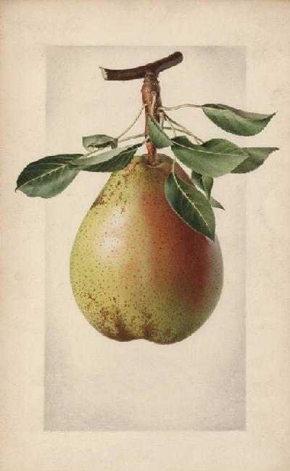
My Pear Mead
John Smith
2003
My Pear Mead
John Smith
2003
My Pear Mead
John Smith
2003
My Pear Mead
John Smith
2003
Label copyright (c) 2004 Joyce C. Hersh
Label copyright (c) 2004 Joyce C. Hersh
Label copyright (c) 2004 Joyce C. Hersh
Label copyright (c) 2004 Joyce C. Hersh

