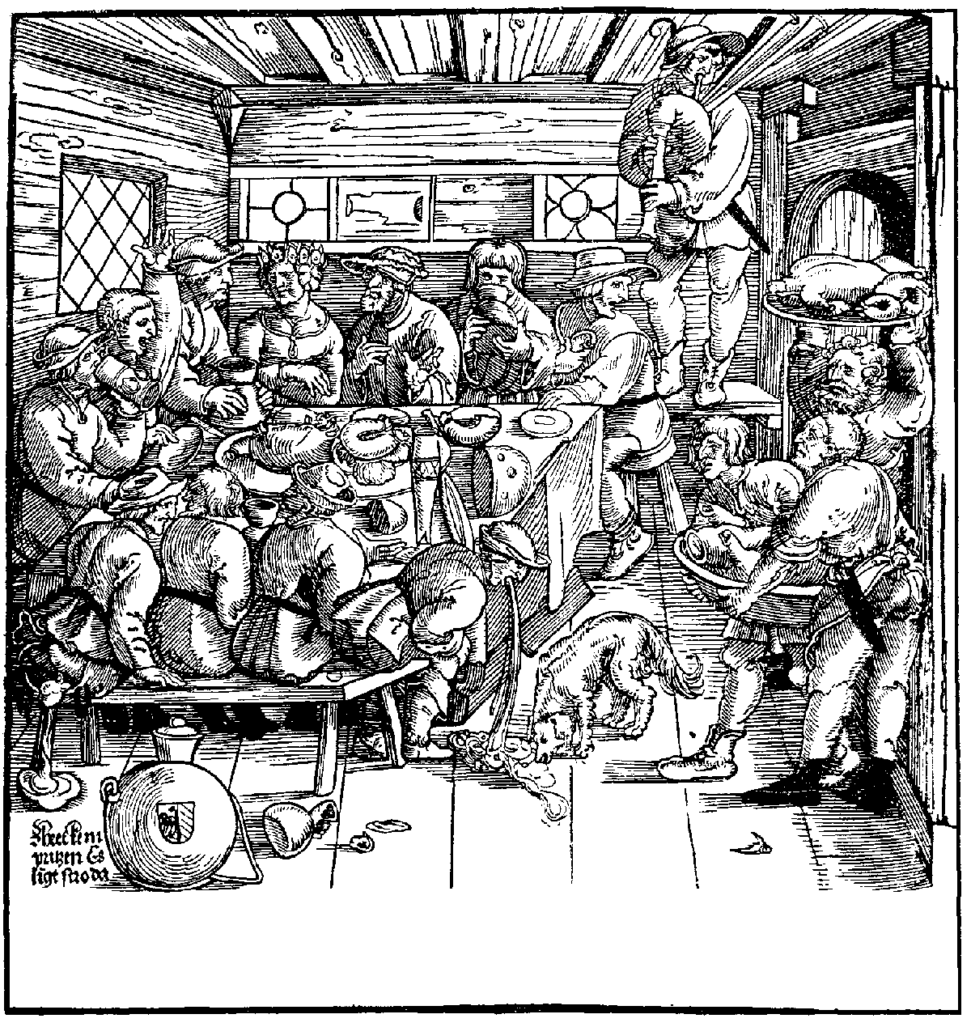
John & Jane’s Wedding Brew May 2000
John & Jane’s Wedding Brew May 2000
John & Jane’s Wedding Brew May 2000
John & Jane’s Wedding Brew May 2000
John & Jane’s Wedding Brew May 2000
John & Jane’s Wedding Brew May 2000
Label copyright (c) 2004 Joyce C. Hersh
Label copyright (c) 2004 Joyce C. Hersh
Label copyright (c) 2004 Joyce C. Hersh
Label copyright (c) 2004 Joyce C. Hersh
Label copyright (c) 2004 Joyce C. Hersh
Label copyright (c) 2004 Joyce C. Hersh

