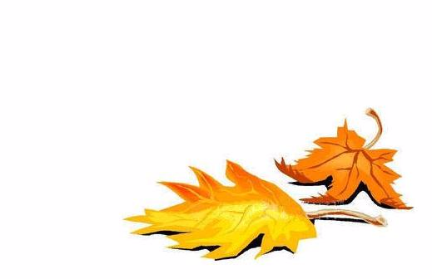

Maple Wine

John Smith 2003

Maple Wine

John Smith 2003
Label copyright (c) 2004 Joyce C. Hersh
Label copyright (c) 2004 Joyce C. Hersh

Maple Wine

John Smith 2003

Maple Wine

John Smith 2003
Label copyright (c) 2004 Joyce C. Hersh
Label copyright (c) 2004 Joyce C. Hersh

Maple Wine

John Smith 2003

Maple Wine

John Smith 2003
Label copyright (c)
2004 Joyce C. Hersh
Label copyright (c) 2004 Joyce C. Hersh

Maple Wine

John Smith 2003

Maple Wine

John Smith 2003
Label copyright (c) 2004 Joyce C. Hersh
Label copyright (c) 2004 Joyce C. Hersh

