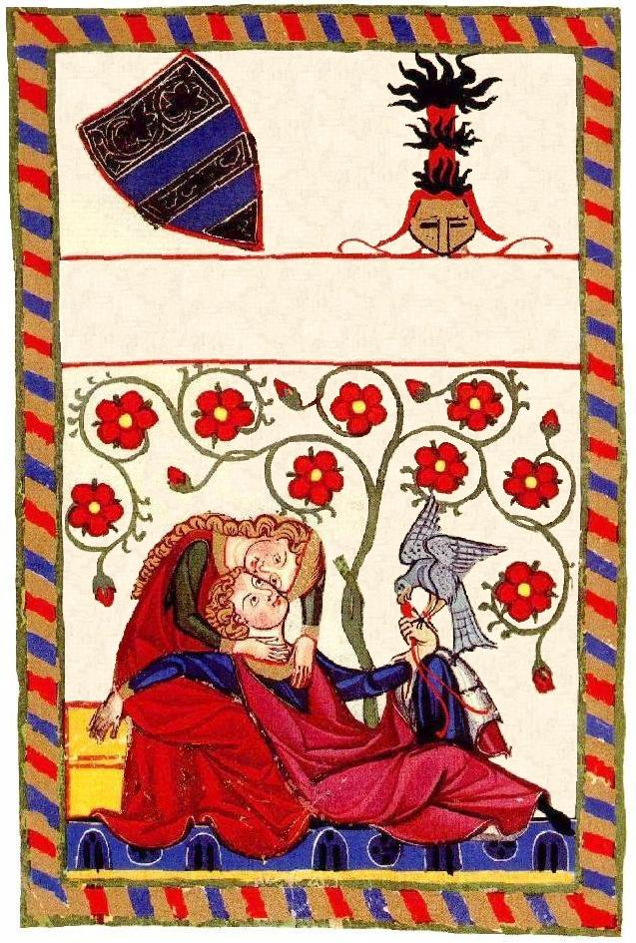
Valentine’s Day Wine
John Smith 2000
Valentine’s Day Wine
John Smith 2000
Valentine’s Day Wine
John Smith 2000
Valentine’s Day Wine
John Smith 2000
Label copyright (c) 2004 Joyce C. Hersh

Label copyright (c) 2004 Joyce C. Hersh

Label copyright (c) 2004 Joyce C. Hersh

Label copyright (c) 2004 Joyce C. Hersh

