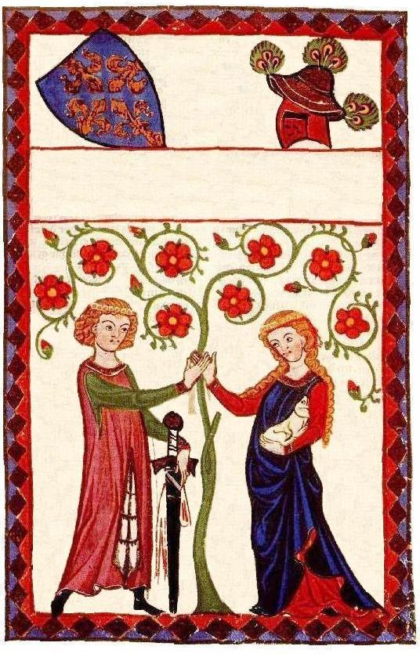
John & Jane’s Wedding
Chardonnay 2000
John & Jane’s Wedding
Chardonnay 2000
John & Jane’s Wedding
Chardonnay 2000
John & Jane’s Wedding
Chardonnay 2000
Label copyright (c) 2004 Joyce C. Hersh

Label copyright (c) 2004 Joyce C. Hersh

Label copyright (c) 2004 Joyce C. Hersh
Label copyright (c) 2004 Joyce C. Hersh

