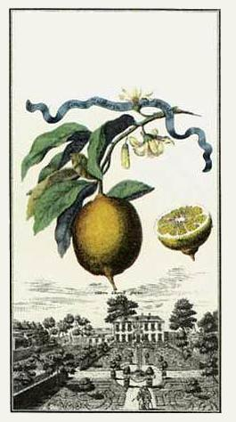
Lemon Mead
John Smith
2003
Lemon Mead
John Smith
2003
Lemon Mead
John Smith
2003
Lemon Mead
John Smith
2003
Lemon Mead
John Smith
2003
Lemon Mead
John Smith
2003
Label copyright (c) 2004 Joyce C. Hersh
Label copyright (c) 2004 Joyce C. Hersh

Label copyright (c) 2004 Joyce C. Hersh

Label copyright (c) 2004 Joyce C. Hersh

Label copyright (c) 2004 Joyce C. Hersh

Label copyright (c) 2004 Joyce C. Hersh

