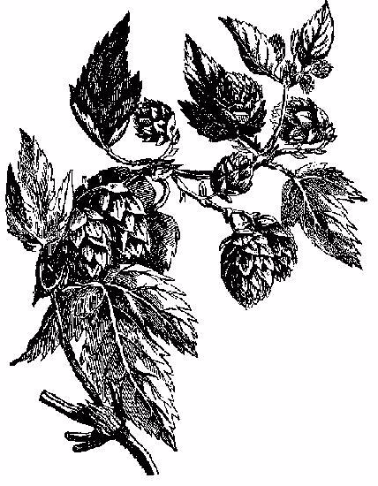

My Great Beer

John Smith
2003
Label copyright (c) 2004 Joyce C. Hersh

My Great Beer

John Smith
2003
Label copyright (c) 2004 Joyce C. Hersh

My Great Beer

John Smith
2003
Label copyright (c) 2004 Joyce C. Hersh

My Great Beer

John Smith
2003
Label copyright (c) 2004 Joyce C. Hersh

My Great Beer

John Smith
2003
Label copyright (c) 2004 Joyce C. Hersh

My Great Beer

John Smith
2003
Label copyright (c) 2004 Joyce C. Hersh

My Great Beer

John Smith
2003
Label copyright (c) 2004 Joyce C. Hersh

My Great Beer

John Smith
2003
Label copyright (c) 2004 Joyce C. Hersh

