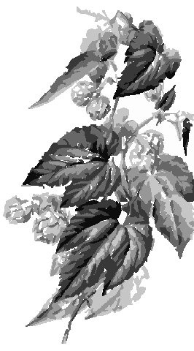
My Great Beer
John Smith
2003
Label copyright (c) 2004 Joyce C. Hersh
My Great Beer
John Smith
2003
Label copyright (c) 2004 Joyce C. Hersh
My Great Beer
John Smith
2003
Label copyright (c) 2004 Joyce C. Hersh
My Great Beer
John Smith
2003
Label copyright (c) 2004 Joyce C. Hersh
My Great Beer
John Smith
2003
Label copyright (c) 2004 Joyce C. Hersh
My Great Beer
John Smith
2003
Label copyright (c) 2004 Joyce C. Hersh
My Great Beer
John Smith
2003
Label copyright (c) 2004 Joyce C. Hersh
My Great Beer
John Smith
2003
Label copyright (c) 2004 Joyce C. Hersh

