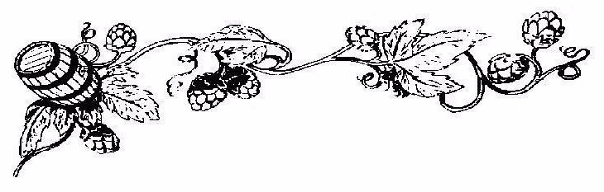
My Great Beer John Smith 2003
My Great Beer John Smith 2003
My Great Beer John Smith 2003
My Great Beer John Smith 2003
My Great Beer John Smith 2003
My Great Beer John Smith 2003
My Great Beer John Smith 2003
My Great Beer John Smith 2003
My Great Beer John Smith 2003
My Great Beer John Smith 2003
My Great Beer John Smith 2003
My Great Beer John Smith 2003
My Great Beer John Smith 2003
My Great Beer John Smith 2003
Label copyright (c) 2004 Joyce C. Hersh
Label copyright (c) 2004 Joyce C. Hersh
Label copyright (c) 2004 Joyce C. Hersh
Label copyright (c) 2004 Joyce C. Hersh
Label copyright (c) 2004 Joyce C. Hersh
Label copyright (c) 2004 Joyce C. Hersh
Label copyright (c) 2004 Joyce C. Hersh
Label copyright (c) 2004 Joyce C. Hersh
Label copyright (c) 2004 Joyce C. Hersh
Label copyright (c) 2004 Joyce C. Hersh
Label copyright (c) 2004 Joyce C. Hersh
Label copyright (c) 2004 Joyce C. Hersh
Label copyright (c) 2004 Joyce C. Hersh
Label copyright (c) 2004 Joyce C. Hersh

