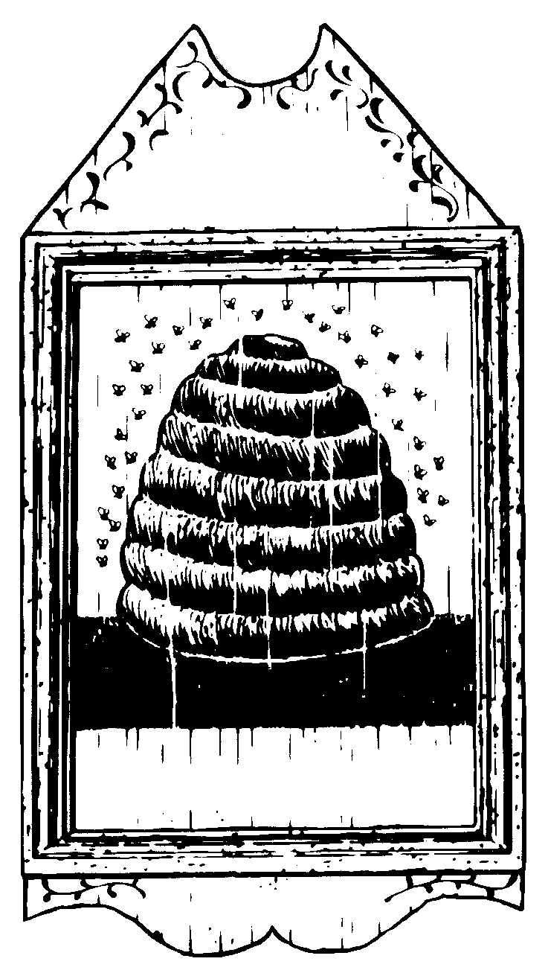
2004
J. S.
Honey Mead
2004
J. S.
Honey Mead
2004
J. S.
Honey Mead
2004
J. S.
Honey Mead
2004
J. S.
Honey Mead
2004
J. S.
Honey Mead
Label copyright (c) 2004 Joyce C. Hersh
Label copyright (c) 2004 Joyce C. Hersh
Label copyright (c) 2004 Joyce C. Hersh
Label copyright (c) 2004 Joyce C. Hersh
Label copyright (c) 2004 Joyce C. Hersh
Label copyright (c) 2004 Joyce C. Hersh

