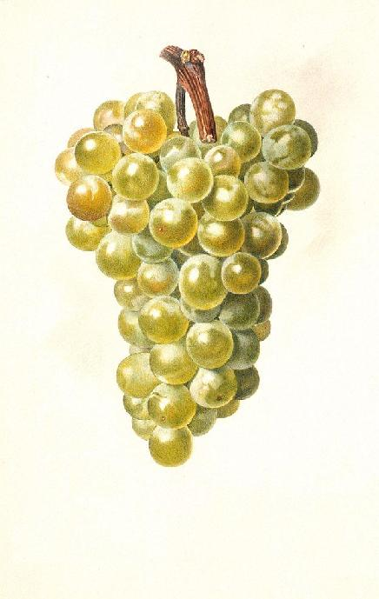
ChardonnayJohn Smith
2003
Label copyright (c) 2004 Joyce C. Hersh
ChardonnayJohn Smith
2003
Label copyright (c) 2004 Joyce C. Hersh
ChardonnayJohn Smith
2003
Label copyright (c) 2004 Joyce C. Hersh
ChardonnayJohn Smith
2003
Label copyright (c) 2004 Joyce C. Hersh

