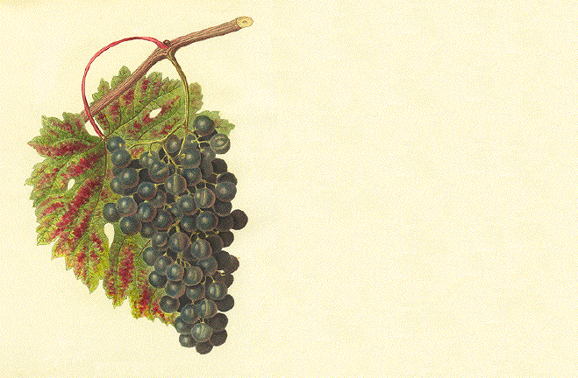

Cabernet

John Smith
2003

Cabernet

John Smith
2003

Cabernet

John Smith
2003

Cabernet

John Smith
2003

Cabernet

John Smith
2003

Cabernet

John Smith
2003

Cabernet

John Smith
2003
Label copyright (c) 2004 Joyce C. Hersh

Cabernet

John Smith
2003
Label copyright (c) 2004 Joyce C. Hersh
Label copyright (c) 2004 Joyce C. Hersh
Label copyright (c) 2004 Joyce C. Hersh
Label copyright (c) 2004 Joyce C. Hersh
Label copyright (c) 2004 Joyce C. Hersh
Label copyright (c) 2004 Joyce C. Hersh
Label copyright (c) 2004 Joyce C. Hersh

