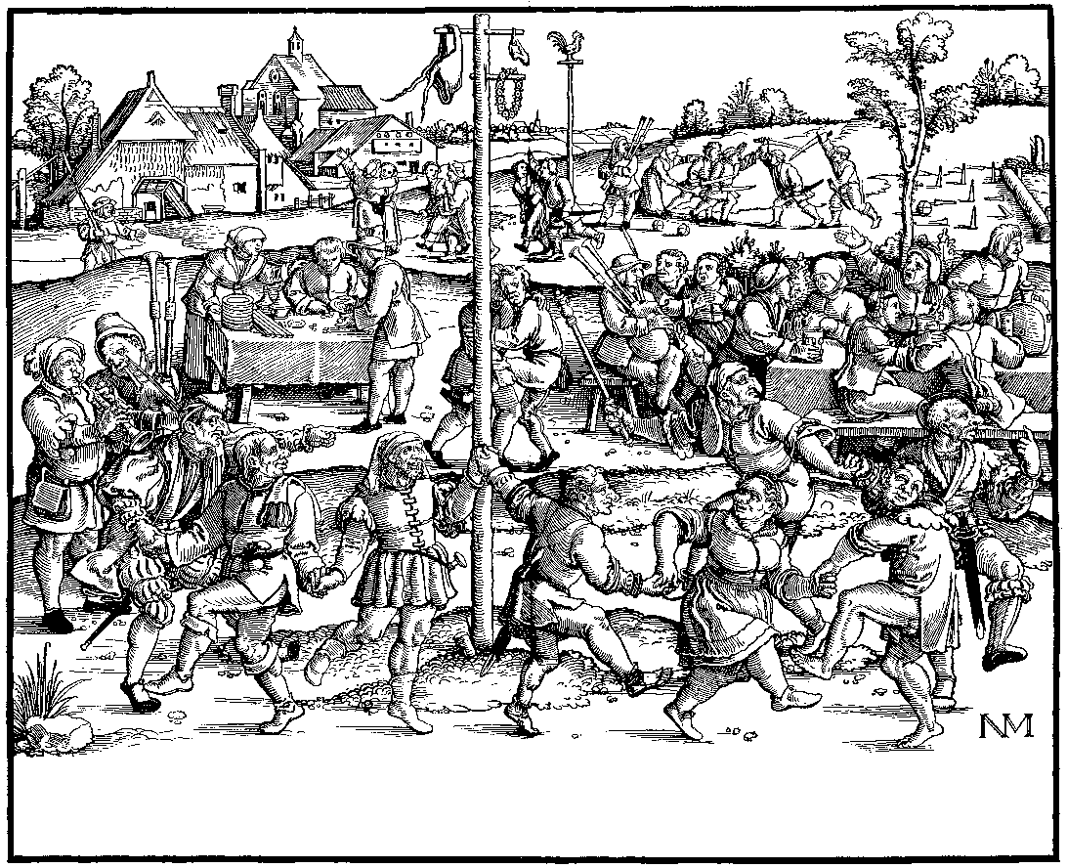
New Year’s Eve Brew 1999-2000
Label copyright (c) 2004 Joyce C. Hersh
New Year’s Eve Brew 1999-2000
Label copyright (c) 2004 Joyce C. Hersh
New Year’s Eve Brew 1999-2000
Label copyright (c) 2004 Joyce C. Hersh
New Year’s Eve Brew 1999-2000
Label copyright (c) 2004 Joyce C. Hersh

