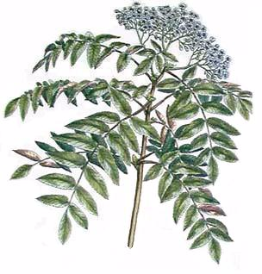

Elderberry
Mead

John Smith
2003
Label copyright (c) 2004 Joyce C. Hersh

Elderberry
Mead

John Smith
2003
Label copyright (c) 2004 Joyce C. Hersh

Elderberry
Mead

John Smith
2003
Label copyright (c) 2004 Joyce C. Hersh

Elderberry
Mead

John Smith
2003
Label copyright (c) 2004 Joyce C. Hersh

Elderberry
Mead

John Smith
2003
Label copyright (c) 2004 Joyce C. Hersh

Elderberry
Mead

John Smith
2003
Label copyright (c) 2004 Joyce C. Hersh

Elderberry
Mead

John Smith
2003
Label copyright (c) 2004 Joyce C. Hersh

Elderberry
Mead

John Smith
2003
Label copyright (c) 2004 Joyce C. Hersh

