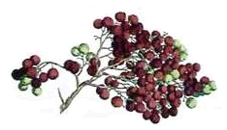
Elderberry Wine
John Smith
2003
Label copyright (c) 2004 Joyce C. Hersh
Elderberry Wine
John Smith
2003
Label copyright (c) 2004 Joyce C. Hersh
Elderberry Wine
John Smith
2003
Label copyright (c) 2004 Joyce C. Hersh
Elderberry Wine
John Smith
2003
Label copyright (c) 2004 Joyce C. Hersh
Elderberry Wine
John Smith
2003
Label copyright (c) 2004 Joyce C. Hersh
Elderberry Wine
John Smith
2003
Label copyright (c) 2004 Joyce C. Hersh
Elderberry Wine
John Smith
2003
Label copyright (c) 2004 Joyce C. Hersh
Elderberry Wine
John Smith
2003
Label copyright (c) 2004 Joyce C. Hersh

