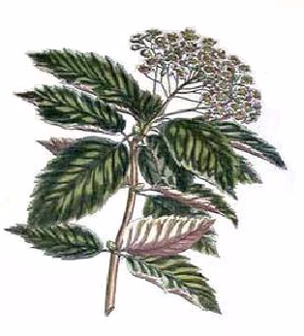
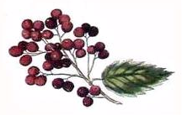
Elderberry
Wine

John Smith
2003
Elderberry
Wine

John Smith
2003
Label copyright (c) 2004 Joyce C. Hersh
Elderberry
Wine

John Smith
2003
Elderberry
Wine

John Smith
2003
Elderberry
Wine

John Smith
2003
Elderberry
Wine

John Smith
2003
Elderberry
Wine

John Smith
2003
Elderberry
Wine

John Smith
2003
Label copyright (c) 2004 Joyce C. Hersh
Label copyright (c) 2004 Joyce C. Hersh
Label copyright (c) 2004 Joyce C. Hersh
Label copyright (c) 2004 Joyce C. Hersh
Label copyright (c) 2004 Joyce C. Hersh
Label copyright (c) 2004 Joyce C. Hersh
Label copyright (c) 2004 Joyce C. Hersh
Elderberry
Wine

John Smith
2003

