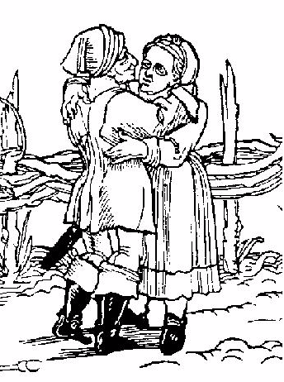
John & Jane’s Wedding
May 2000
John & Jane’s Wedding
May 2000
John & Jane’s Wedding
May 2000
John & Jane’s Wedding
May 2000
John & Jane’s Wedding
May 2000
John & Jane’s Wedding
May 2000
John & Jane’s Wedding
May 2000
John & Jane’s Wedding
May 2000
John & Jane’s Wedding
May 2000
Label copyright (c) 2004 Joyce C. Hersh
Label copyright (c) 2004 Joyce C. Hersh
Label copyright (c) 2004 Joyce C. Hersh
Label copyright (c) 2004 Joyce C. Hersh
Label copyright (c) 2004 Joyce C. Hersh
Label copyright (c) 2004 Joyce C. Hersh
Label copyright (c) 2004 Joyce C. Hersh
Label copyright (c) 2004 Joyce C. Hersh
Label copyright (c) 2004 Joyce C. Hersh

