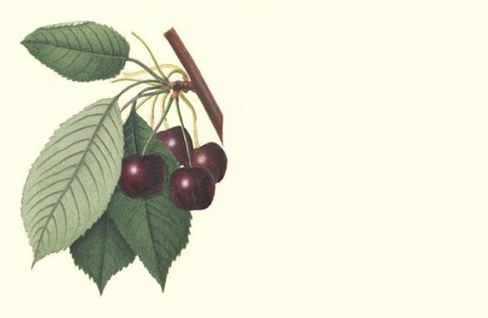

Cherry
Wine

John Smith
2003
Label copyright (c) 2004 Joyce C. Hersh

Cherry
Wine

John Smith
2003
Label copyright (c) 2004 Joyce C. Hersh

Cherry
Wine

John Smith
2003
Label copyright (c) 2004 Joyce C. Hersh

Cherry
Wine

John Smith
2003
Label copyright (c) 2004 Joyce C. Hersh

Cherry
Wine

John Smith
2003
Label copyright (c) 2004 Joyce C. Hersh

Cherry
Wine

John Smith
2003
Label copyright (c) 2004 Joyce C. Hersh

Cherry
Wine

John Smith
2003
Label copyright (c) 2004 Joyce C. Hersh

Cherry
Wine

John Smith
2003
Label copyright (c) 2004 Joyce C. Hersh

