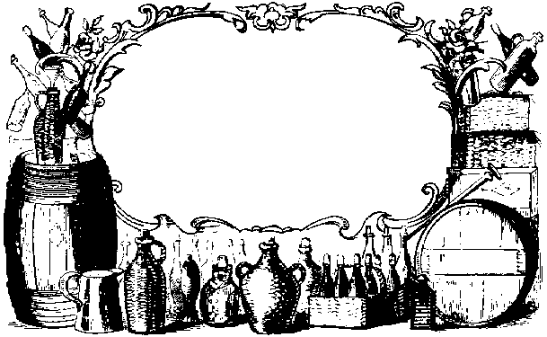
My Great Wine
2000
John Smith
Label copyright (c) 2004 Joyce C. Hersh
My Great Wine
2000
John Smith
Label copyright (c) 2004 Joyce C. Hersh
My Great Wine
2000
John Smith
Label copyright (c) 2004 Joyce C. Hersh
My Great Wine
2000
John Smith
Label copyright (c) 2004 Joyce C. Hersh
My Great Wine
2000
John Smith
Label copyright (c) 2004 Joyce C. Hersh
My Great Wine
2000
John Smith
Label copyright (c) 2004 Joyce C. Hersh
My Great Wine
2000
John Smith
Label copyright (c) 2004 Joyce C. Hersh
My Great Wine
2000
John Smith
Label copyright (c) 2004 Joyce C. Hersh

