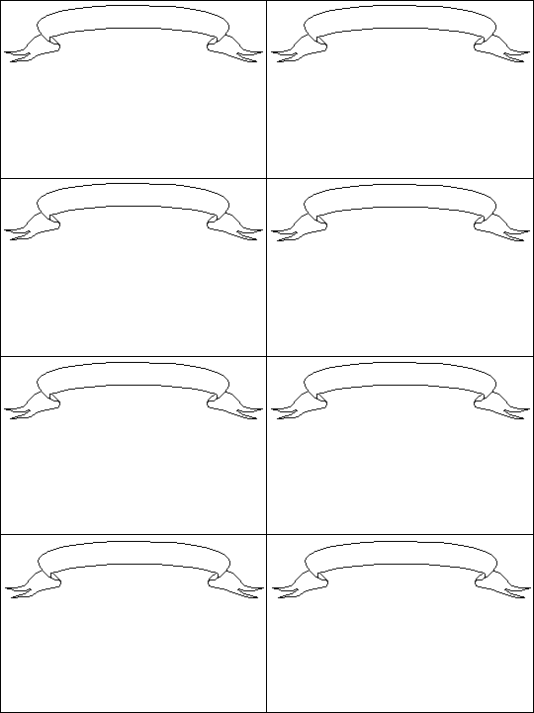
My Great Beer

John Smith 2003
My Great Beer

John Smith 2003
My Great Beer

John Smith 2003
My Great Beer

John Smith 2003
My Great Beer

John Smith 2003
My Great Beer

John Smith 2003
My Great Beer

John Smith 2003

