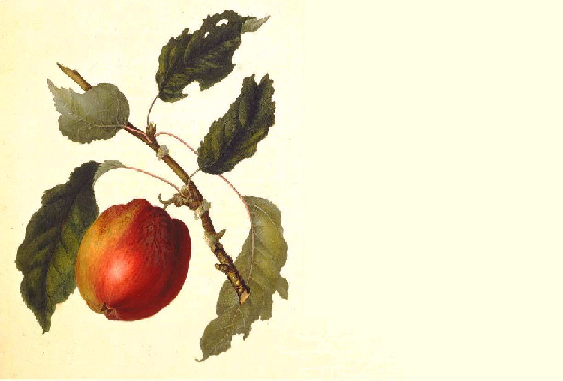

Cyser

John Smith
2003
Label copyright (c) 2004 Joyce C. Hersh

Cyser

John Smith
2003
Label copyright (c) 2004 Joyce C. Hersh

Cyser

John Smith
2003
Label copyright (c) 2004 Joyce C. Hersh

Cyser

John Smith
2003
Label copyright (c) 2004 Joyce C. Hersh

Cyser

John Smith
2003
Label copyright (c) 2004 Joyce C. Hersh

Cyser

John Smith
2003
Label copyright (c) 2004 Joyce C. Hersh

Cyser

John Smith
2003
Label copyright (c) 2004 Joyce C. Hersh

Cyser

John Smith
2003
Label copyright (c) 2004 Joyce C. Hersh

